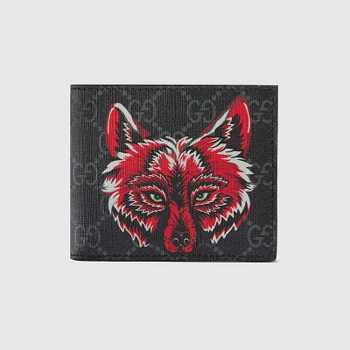

GG Supreme wallet with wolf

PRODUCT DETAILS

**Each season the GG motif is enriched with new prints and motifs. Animals associated**

**with the House are specially printed to create a three-dimensional effect. The wolf head**

**is found throughout the Cruise 2019 collection, set against GG Supreme canvas in black**

**and grey.**

**Gucci Bestiary • Eight card slots and two bill compartments • Made in Italy**